South Littleton Parish Council
Biodiversity Policy 2025
Introduction – What we are doing for your local area to enhance the biodiversity
In the parish of South Littleton, we are actively
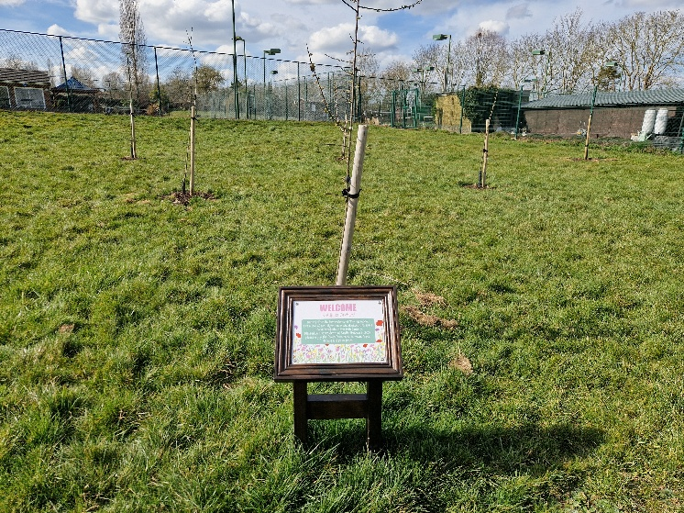
- Planting trees both fruit and native

- Planting native bulbs to encourage more wildlife 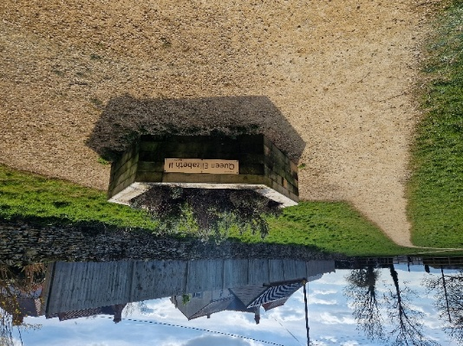

- Cleaning and keeping clear the Gate Inn brook in South Meadows area to alleviate flooding and encourage wildlife back to it.
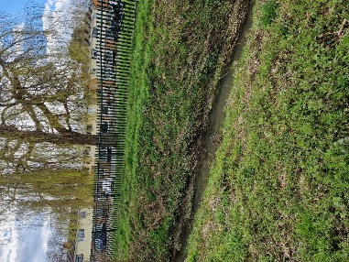

- Willow tunnels which have started to
- establish themselves

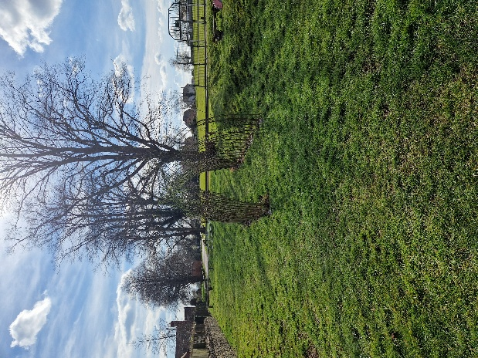

- Maintaining the brook & willow trees at Littleton Brook
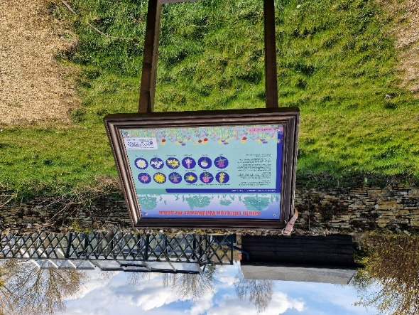
- The Wild flower meadow at the top of the recreation ground on Long Hyde Road
- Creating dedicated wildlife areas
- Using our own leaf mold to mulch the new trees
- Working with the allotment holders to be as environmentally friendly as possible.
- Maintaining the trees that are already planted
- Replacing dead trees with at least double the amount
Going forwards into the future we would like aim towards with the local communities involvement
- Snowdrop & bluebell planting
- Wild Garlic planting
- Wild Seed Harvesting of permitted species for exchange
- Hedging on Long Hyde Road to provide a wild life corridor
- Bug Hotels
- Growing a Christmas Tree in place of buying them
- A wildlife Pond

What we are required to do:
In accordance with the duty imposed on town and parish councils by Section 40 of the Natural Environment and Rural Communities Act 2006, updated by Section 102 of the Environment Act 2021, South Littleton Parish Council will, in exercising all its functions, have regard to the purpose of conserving biodiversity.
It is also important to consider changes to planning requirements enacted through the Environment Act 2021. There is now a requirement, with a few exceptions, for a 10% biodiversity net gain to any new development proposed.

DEFINITION
According to DEFRA (Biodiversity 2020), biodiversity is the variety of all life on Earth. It includes all species of animals and plants – everything that is alive on our planet.
Biodiversity is important for its own sake and has its own intrinsic value. A number of studies have shown this value also goes further. It is the building block of our ‘ecosystems’. These provide us with a wide range of goods and services that support our economic and social wellbeing. These include essentials such as food, fresh water and clean air, but also less obvious services such as protection from natural disasters, regulation of our climate, and purification of our water or pollination of our crops. Biodiversity also provides important cultural services, enriching our lives. Further, there is increasing evidence of the part nature plays in improving our mental and physical health.

AIMS AND OBJECTIVES
The object of this policy is to work towards enhancing and protecting the biodiversity of South Littleton Parish.
All committees of South Littleton Parish will consider sustainability, environmental impact and biodiversity when making decisions and will develop and implement policies and strategies as required.
In particular, South Littleton Parish Council will aim to improve the biodiversity of the area in the following ways:
· consider the potential impact on biodiversity represented by planning applications together with the possibilities of improvement through biodiversity net gain (BNG)
· manage its land and property using environmentally friendly practices that will promote biodiversity.
· support and encourage local businesses if requested in the adoption of low impact practices.
· support and encourage residents and local organisations’ activities to enhance and promote biodiversity.

South Littleton Parish Council
Biodiversity Action Plan 2025

South Littleton Parish Council’s Biodiversity Action Plan uses information provided by Worcestershire County Council’s Biodiversity Action Plan (BAP) and the initial Biodiversity Action Plan created by Wychavon District Council. Sections appropriate to South Littleton Parish have been selected and enhanced to support appropriate actions.
Sections on relevant habitats and species are provided.
Bird species may be referred to as red or amber listed. This references the British Trust for Ornithology’s (BTO) list of endangered birds, red being the most endangered species.
Both habitats and species information includes where it is Natural Environment and Rural Communities (NERC) Act 2006, section 41 listed or where protection is provided through the Wildlife & Countryside Act 1981. It is also noted where a species is a UK Biodiversity Action Plan Priority Species.
It is noted if a species has been seen in South Littleton Parish.

Useful Information Sources

People’s Trust for Endangered Species - www.ptes.org
Hedgehog Street - www.hedgehogstreet.org
The Wildlife Trusts- www.wildlifetrusts.org
RSPB www.rspb.org.uk
Plantlife www.plantlife.org.uk
Buglife www.buglife.org.uk
Woodland Trust www.woodlandtrust.org.uk
Royal Horticultural Society www.rhs.org.uk
Rivers Trust www.riverstrust.org

Bibliography

Websites:
www.worcestershire.gov.uk (Biodiversity Action Plan)
www.bto.org (British Trust for Ornithology)
www.wildlifetrusts.org (The Wildlife Trusts)
www.woodlandtrust.org.uk (The Woodland Trust)

Legislation:

Wildlife and Countryside Act 1981
Natural Environment and Rural Communities (NERC)
Act 2006
Environment Act 2021

